**CP Club 365Days Challenge**

**Date – 18/11/2022**

**Programming language – only C++ language**

**Problem Statement**

**Code must be in C language only**

[https://practice.geeksforgeeks.org/problems/reverse-words-in-a-given-string5459/1?page=1&category[]=Strings&sortBy=submissions](https://practice.geeksforgeeks.org/problems/reverse-words-in-a-given-string5459/1?page=1&category%5b%5d=Strings&sortBy=submissions)

**Your Code**:

// Day 0X32

// VEDANT BHARAD

// 18-11-2022

//{ Driver Code Starts

#include <bits/stdc++.h>

using namespace std;

// } Driver Code Ends

class Solution

{

    public:

    //Function to reverse words in a given string.

    int totalnum(string s)

    {

        int con=0;

        for(int loop=0;loop<s.length();loop++)

        {

            if(s[loop]=='.')

            {

                con++;

            }

        }

        return (con+1);

    }

    string reverseWords(string S)

    {

        string forRET="";

        string arr[totalnum(S)];

        stringstream ss(S);

        string word;

        int index=0;

        int loop;

        while (!ss.eof()) {

            getline(ss, word, '.');

            arr[index]=word;

            index++;

        }

        for(loop=totalnum(S)-1;loop>=0;loop--)

        {

            forRET=forRET+arr[loop]+".";

        }

        forRET.pop_back();

        return forRET;

    }

};

//{ Driver Code Starts.

int main()

{

    int t;

    cin >> t;

    while (t--)

    {

        string s;

        cin >> s;

        Solution obj;

        cout<<obj.reverseWords(s)<<endl;

    }

}

// } Driver Code Ends

**Output (Screen Shot)**:

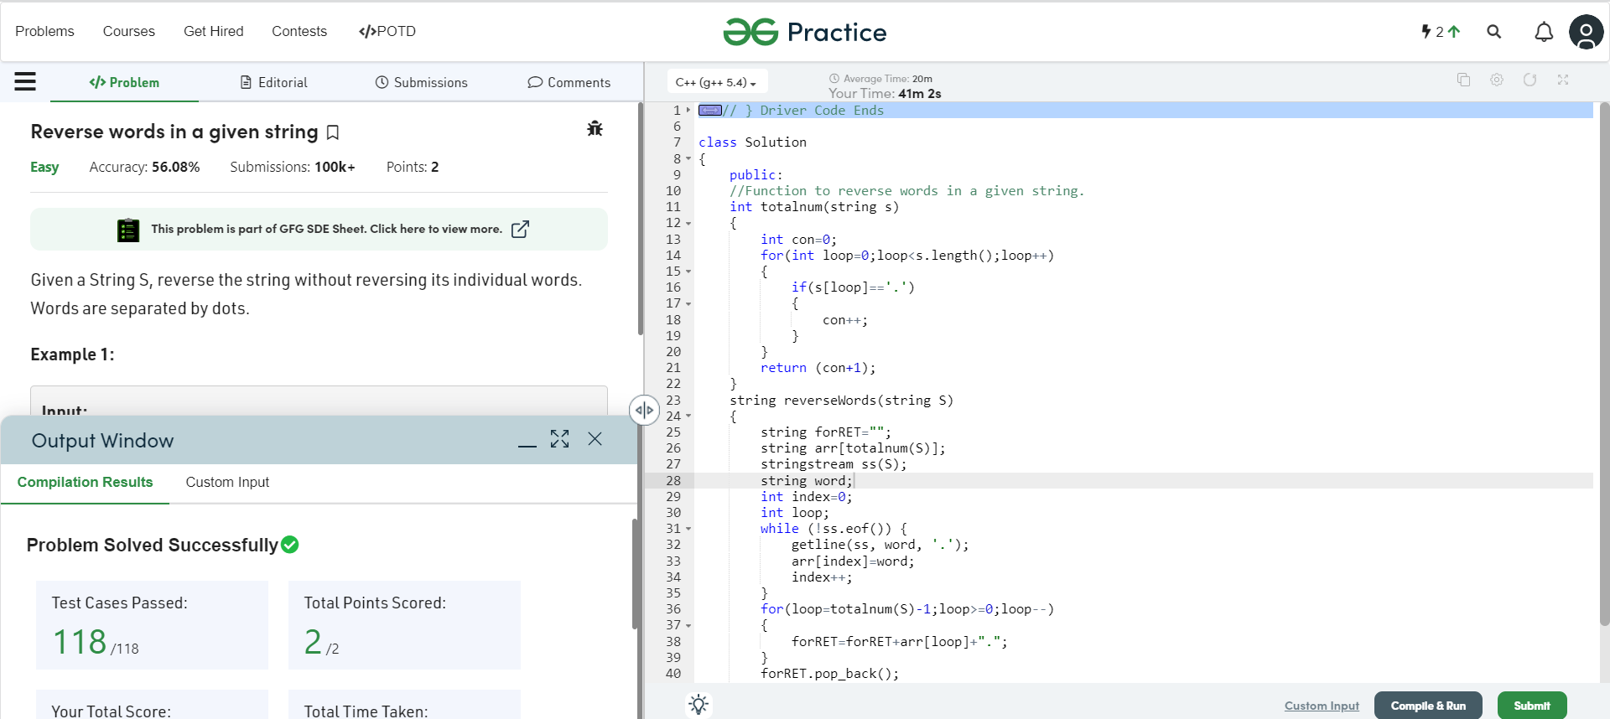

**Understanding about problem:**

* In this task there is one input and in that there will be string with “.” After every word.
* In this take I need to change position of word (in reversed form).

Note: If you can't understand the problem, feel free to contact us and we'll help you. Please don't copy and paste from anywhere.

ALL THE BEST

Team CP Club